**Part 1 - Project**

1. Paste a **clickable**link to your public GitHub repo: [https://github.com/S541931/df-mod1-autopsyLinks to an external site.](https://github.com/S541931/df-mod1-autopsy)
2. Tell us about your project: I did project 1-1, the suspicious death of Sylvias. Joshua Zarkan found her dead and reported it. Law enforcement seized a USB drive and we are looking through the files using Autopsy to find an evidences.
3. About how long did you spend on this module: Maybe 6 Hours total but I was distracted while reading the book so the time it took me to read the chapter was inflated.
4. In general, how did it go: The Case file seemed too barebones (It only had two files to look at) to do much with Autopsy, I think ill do another this weekend, but I don’t have time before the deadline.  
   Graphical user interface, text, application, email

   Description automatically generated
5. What was the most difficult part: GitHub does not support HTML files from Autopsy Reports, I created, I created a report via excel and took screenshots of the HTML report.
6. What was most interesting: Looking at the file Metadata. Both the assets file and suicide note were created in 2005 but modified in 2002 which makes no sense. The assets file (6-Sylvias Assets.xls) was created by Amelia Philips and not “Sylvias”, who was mentioned in the suicide note, a single second before the suicide note was created. Also some Data artifacts show Sylvias Assets.xls being created in 2002 inconsistent with the creation date in the metadata and Timeline Editor tool.  
   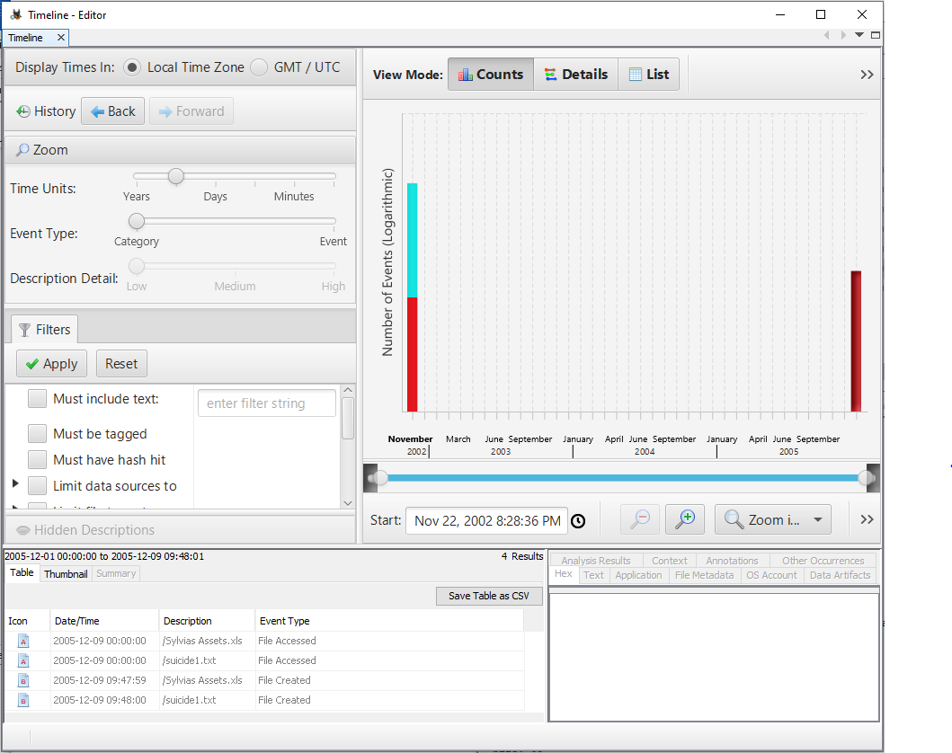  
   Shows the Date Created as "2005-12-09" in the Timeline Editor tool.Graphical user interface, application

   Description automatically generated  
   Shows the Date Modified as "2002-11-22" in the Timeline Editor tool.  
   Graphical user interface, text, email

   Description automatically generated  
   Data Artifacts Show it was created by Amelia Philips dated "2002-11-23" which conflicts with both the creation date of the files metadata and Timeline Editor Tool  
   Graphical user interface, text, application, email

   Description automatically generated  
   Metadata showing the 2005 creation date
7. Did you do the optional bonus (y/n). How did it go - or why not? I think so but I wasn’t sure what to do to get bonus with this first assignment, it was too barebones like I said before, I couldn't explore autopsy fully with it.

**Part 2 - Self Assessment**

1. Describe the digital forensics profession and types of investigations. L01: Proficient
2. Describe the different types of digital devices that can be examined. L01: Proficient
3. Demonstrate the ability to install current digital forensics tools. L03: Highly Proficient
4. Demonstrate the ability to access a forensic disk image and analyze it on your machine. L03,L04,L05: Proficient